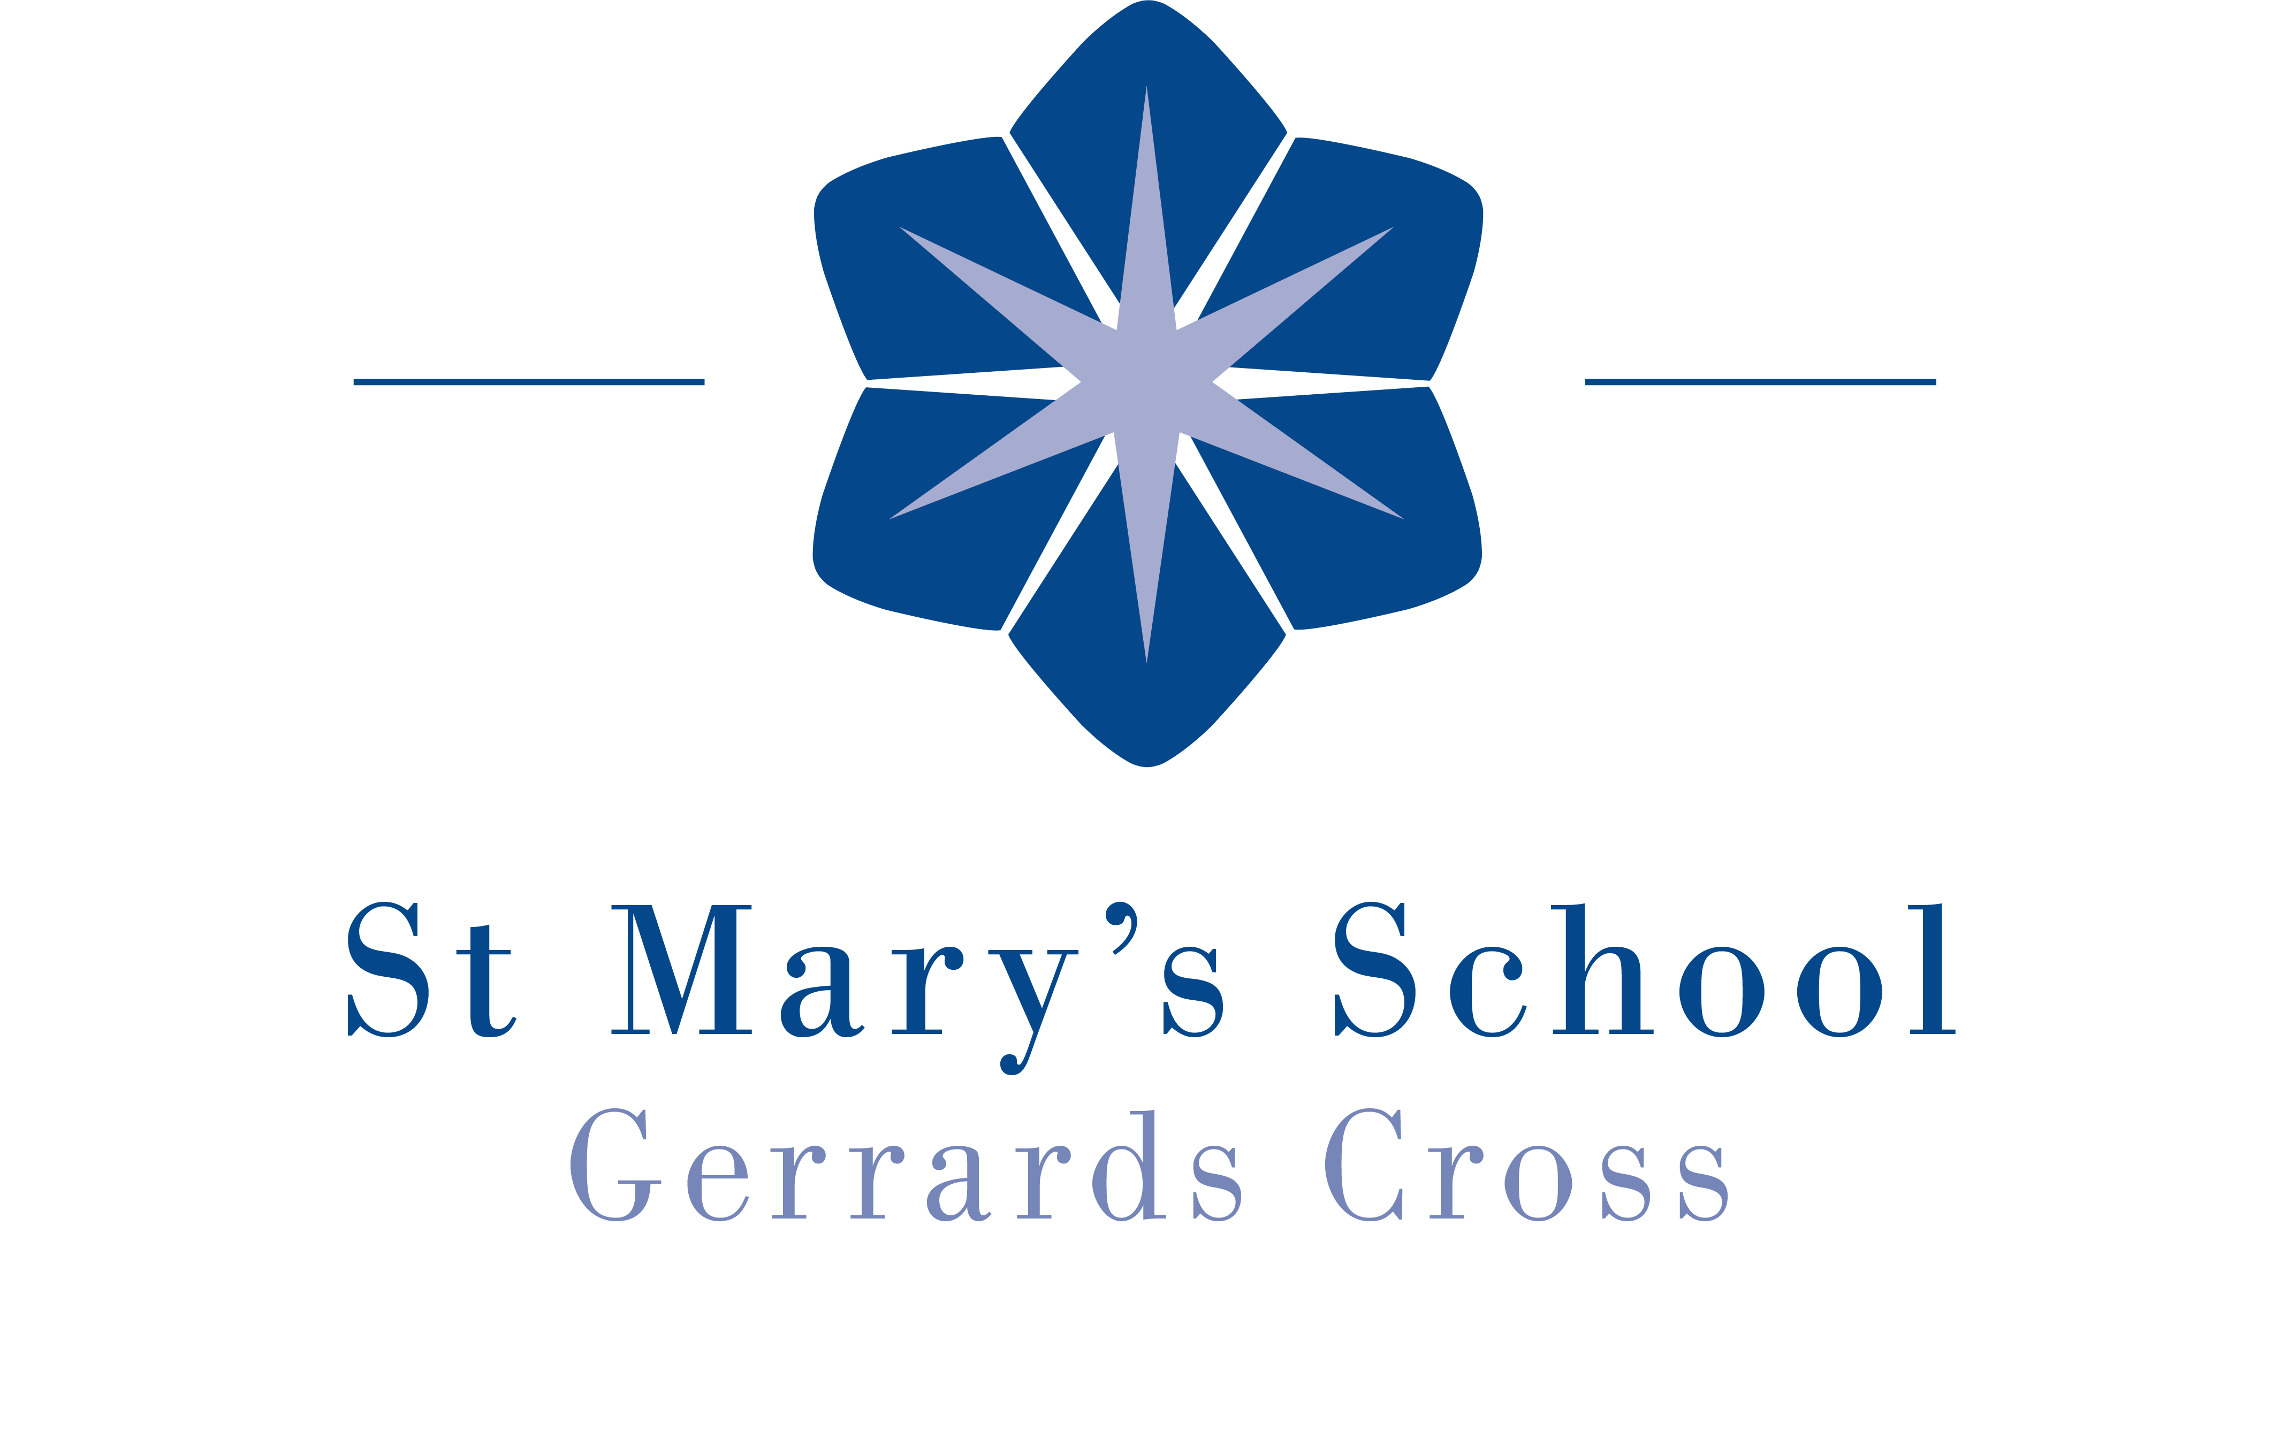
ST MARY’S SCHOOL

Gerrards Cross, Buckinghamshire, SL9 8JQ

APPLICATION FORM
To help us assess your application, please complete all sections of this application form and return it to us with your letter of application. The information provided will be treated as confidential. Any offer of employment will be subject to the results of pre-employment checks. The School is legally required to carry out a number of pre-employment checks which are detailed in the School’s Recruitment Policy.

Position Applied For:

How Did You Hear About This Job Vacancy?

Personal Details

Title:

First Names:

Surname:

Previous name(s):

Address:

Do you have Qualified Teacher Status? Yes No

Teacher Reference No:

National Insurance Number:

Home Telephone No:

Mobile Telephone No:

Postcode:

Email Address:

Current Driving Licence: Yes No Endorsements? Yes No

Are you registered with the DBS update service? Yes No

DBS Update certificate number

Please give details of any current endorsements if applicable:

Education and Qualifications

Please give details of Secondary and Further Education including any A Levels or equivalent vocational courses (indicating the most recent one first).
Dates (mm/yyyy)  From To |  | College/Other Institution | Qualifications Obtained | Grade or Level
Please give details of any Higher Education courses (indicating the most recent one first).
Dates (mm/yyyy)  From To |  | College/University  (and name of awarding body) | Qualifications/Degree Obtained |  | Grade or Level

Please give details of any other Professional / Vocational qualifications or Training courses attended relevant to your application.
Dates (mm/yyyy)  From To |  | College/Training institution (and name of awarding body) | Qualifications Obtained | Grade or Level

Employment History
Please complete details of your present and previous employment as requested below. Please state whether full-time or part-time and include any voluntary employment. Continue on a separate sheet if necessary.
Present (or Most Recent) Employment
Job title: Employer:

Current Salary: Address:

Employment From: Employment To:

When would you be available to commence employment at St Mary’s School?

For this employment, please give a brief description of duties, responsibilities and achievements:

Reason for seeking other employment:

Previous Employment
(Please indicate the most recent previous employment first and continue on another sheet if required)
Dates (mm/yyyy)  From To |  | Name of Employer | Job Title and Main  Responsibilities | Reason for Leaving

If there are any gaps in your Employment or Education History, please explain them here

Referees
Please supply the names and contact details of two people we may contact for references. One of these must be your current or most recent employer. If your current / most recent employment
does / did not involve work with children, then your second referee should be from the employer with whom you most recently worked with children. Neither referee should be a relative or someone known to you solely as a friend. The school intends to take up references from all shortlisted candidates before interview. The school reserves the right to take up references from any previous employer.
Referee 1

Name: Position:

In what capacity do you know the referee?

Name of Organisation:

Address:

Telephone No: Email:

Referee 2

Name: Position:

In what capacity do you know the referee?

Name of Organisation:

Address:

Telephone No: Email:

May we approach your referees without further reference to you? Yes No
Other
Are you related to or do you maintain a close relationship with an existing employee, volunteer, pupil, Governor or Trustee of St Mary’s School? Yes No

If ‘Yes’ please give the name of the related person:

Employment in the United Kingdom
Do you have any restrictions on being resident or employed in the UK? Yes No
Please give full details:

Have you lived/worked outside of the UK for three months or more in the past five years?
Yes No
Please give details:

Interests (both Professional and Leisure)
Details of any co-curricular activity you can offer:
Details and level of any other teaching subjects you can offer:

Personal Statement
Please give your reasons for applying for this post and say why you believe you are suitable for the position. Study the job description and person specification and describe any experience and skills you have gained in other jobs or similar environments which demonstrate your ability and aptitude to undertake the duties of the post. Continue on a separate sheet if necessary.

Recruitment
It is the School's policy to employ the best qualified personnel and to provide equal opportunity for the advancement of employees including promotion and training and not to discriminate against any person because of their race, colour, national or ethnic origin, sex, sexual orientation, marital or civil partnership status, religion or religious belief, disability or age. All new appointments are subject to a probationary period.
Have you read the School’s Recruitment Policy? Yes No
This policy can be read on our website at:
https://stmarysschool.co.uk/wp-content/uploads/2020/09/18a-Recrutiment.pdf

The School is committed to safeguarding and promoting the welfare of children and young people and expects all staff and volunteers to share this commitment.
Have you read the School’s Safeguarding and Child Protection Policy? Yes No
This policy can be read on our website at:
https://stmarysschool.co.uk/wp-content/uploads/2021/09/7a-Safeguarding-1.pdf

If your application is successful, the School will retain the information provided in this form (together with any attachments) on your personnel file. If your application is unsuccessful, all documentation relating to your application will normally be confidentially destroyed six months after the date which you are notified of the outcome.
Would you like the school to retain your details if your application is unsuccessful? Yes No

Are there any special arrangements you might require to attend an interview? Yes No

If yes, please give details here: ………………………………………………………………………………………………………

Data Protection Statement:
The information that you provide on this form and that obtained from other relevant sources will be used to process your application for employment. The personal information that you give us may also be used in a confidential manner to help us monitor our recruitment process. If you succeed in your application and take up employment with us, the information will be used in the administration of your employment. We may check the information collected, with third parties or with other information held by us. Your details will not be passed to any third parties unconnected with St Mary’s School, except where required by law. By signing this application form we will be assuming that you agree to the processing of sensitive personal data, (as described above), in accordance with the General Protection and Data Protection Act 2018.

Declaration – Please read carefully

Declaration:
I certify to the best of my knowledge and belief that the information given in this application is true and accurate. I understand that if the information is false or misleading it will disqualify me from appointment or after appointment could lead to a disciplinary action or dismissal. I acknowledge that where this form is submitted electronically and without a signature, electronic receipt of this form by the employer will be deemed equivalent to submission of a signed version and will constitute confirmation of the declaration.

Signed: Date:

Printed Name:

Please either print this form and send a signed, hard copy and a letter of application to:

Mrs P Adams, Headmistress, St Mary’s School, Packhorse Road, Gerrards Cross, Bucks SL9 8JQ

or return the form via email to hradmin@st-marys.bucks.sch.uk together with a letter of application.
If sent electronically, please note that you will be required to sign and date the application form if invited to attend an interview.

Equal Opportunities Monitoring Form
You are not obliged to complete this form but it is helpful to the School for maintaining equal opportunities. All information provided will be treated in confidence. The form will be detached from your application and kept separately.

St Mary’s School recognises and is committed to ensuring applicants from all sections of the community are treated equally regardless of race, gender, disability, age, sexual orientation, religion or belief, gender reassignment, marital and civil partnership status, or pregnancy and maternity.

Full Name:
Gender:
Date of Birth:

Ethnic Origin
(These categories of ethnic monitoring are recommended by the UK Equal Opportunities Commission as the most appropriate for the UK. If none of these categories fit your own ethnicity then please tick the ‘Other Ethnic Group’ box and define).
Asian or  Asian British | Mixed | Chinese or  other racial
- Indian  - Pakistani  - Bangladeshi  - Other | - White & Black Caribbean  - White & Black African  - White and Asian  - Other Mixed | - Chinese  - Other racial group
Black or  Black British | White | Other Ethnic Group
- Black Caribbean  - Black African  - Other Black | - British  - Irish  - Other White
Religion
- Buddhist | - Jewish | - No Religion
- Christian | - Muslim | - Other (Please write in)
- Hindu | - Sikh | - Other (Please write in)
Do you consider yourself to have a disability? Yes/No
If Yes, what is the nature of your disability?

Status
- Single | - Civil Partnership | - Prefer not to say
- Married | - Living with Partner

